DATA QUALITY

Task 6 - SQL Reconciliation Report
Tamar Tutisani

Contents
DATA QUALITY 1
Task 6 - SQL Reconciliation Report 1
Executive Summary 3
1 Approach 3
2 Setup scripts 4
3 Reconciliation queries 4
3.1 s1.s1_clients vs lnd.lnd_s1_clients 4
3.2 s1.s1_products vs lnd.lnd_s1_products 5
3.3 s2.s2_channels vs lnd.lnd_s2_channels 5
3.4 s2.s2_locations vs lnd.lnd_s2_locations 6
3.5 s2.s2_clients vs lnd.lnd_s2_clients (composite key: client_id + valid_from) 6
3.6 s1.s1_sales vs lnd.lnd_s1_sales (composite key, no natural ID) 7
3.7 s2.s2_client_sales vs lnd.lnd_s2_client_sales (composite key, no natural ID) 8
3.8 Results summary 10
4 Key findings 11
5 Deliverable 11

Executive Summary
This report documents the SQL-based reconciliation performed between the source system database (dwh_src_hw_db) and the landing layer of the target DWH (dwh_hw_db), using PostgreSQL's dblink extension. The goal was to confirm that all records from the source systems (S1, S2) are present and unchanged in the landing layer, and to flag any discrepancies for further investigation.

Approach
- Enabled dblink on the target database to query the source database remotely.
- For each source/landing table pair, performed a FULL OUTER JOIN on the natural or composite primary key, and classified every row into one of: Match, Only in source, Only in target, or Mismatch in <column_name>.
- Used IS DISTINCT FROM instead of <> for all value comparisons, since several compared columns are nullable and <> returns NULL (not TRUE) when either side is NULL, this would silently hide real mismatches involving NULLs.
- For tables without a single natural identifier (s1_sales, s2_client_sales, s2_clients), built composite keys and validated uniqueness of the chosen key combination before joining, to avoid row-multiplication from non-unique joins.
- Stored only problematic rows (status ≠ Match) in a dedicated table, lnd.reconciliation_results, for easy review.
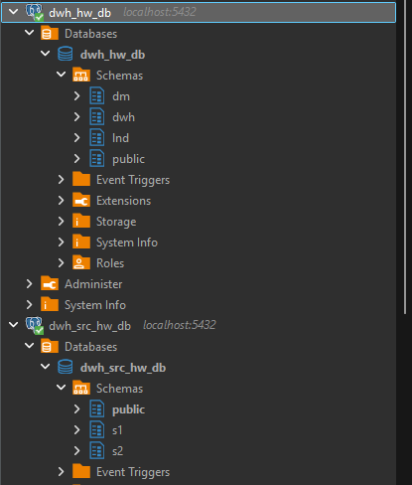
Figure 1. Confirmed schema

Setup scripts
CREATE EXTENSION IF NOT EXISTS dblink;

CREATE TABLE lnd.reconciliation_results (
table_name character varying(256),
key_column character varying(256),
src_id character varying(256),
trg_id character varying(256),
reconciliation_status character varying(256)
);

Reconciliation queries

s1.s1_clients vs lnd.lnd_s1_clients
INSERT INTO lnd.reconciliation_results (table_name, key_column, src_id, trg_id, reconciliation_status)
SELECT table_name, key_column, src_id, trg_id, reconciliation_status
FROM (
SELECT
's1_clients' AS table_name,
'client_id' AS key_column,
src.client_id AS src_id,
trg.client_id AS trg_id,
CASE
WHEN src.client_id IS NULL THEN 'Only in target'
WHEN trg.client_id IS NULL THEN 'Only in source'
WHEN src.first_name IS DISTINCT FROM trg.first_name THEN 'Mismatch in first_name'
WHEN src.middle_name IS DISTINCT FROM trg.middle_name THEN 'Mismatch in middle_name'
WHEN src.last_name IS DISTINCT FROM trg.last_name THEN 'Mismatch in last_name'
WHEN src.email IS DISTINCT FROM trg.email THEN 'Mismatch in email'
WHEN src.phone IS DISTINCT FROM trg.phone THEN 'Mismatch in phone'
WHEN src.first_purchase IS DISTINCT FROM trg.first_purchase THEN 'Mismatch in first_purchase'
ELSE 'Match'
END AS reconciliation_status
FROM lnd.lnd_s1_clients trg
FULL OUTER JOIN (
SELECT * FROM dblink(
'dbname=dwh_src_hw_db user=postgres password=postgres host=localhost',
'SELECT client_id, first_name, middle_name, last_name, email, phone, first_purchase FROM s1.s1_clients'
) AS s(client_id varchar(256), first_name varchar(256), middle_name varchar(256),
last_name varchar(256), email varchar(256), phone varchar(256), first_purchase varchar(256))
) src ON src.client_id = trg.client_id
) result
WHERE reconciliation_status <> 'Match';

s1.s1_products vs lnd.lnd_s1_products
INSERT INTO lnd.reconciliation_results (table_name, key_column, src_id, trg_id, reconciliation_status)
SELECT table_name, key_column, src_id, trg_id, reconciliation_status
FROM (
SELECT
's1_products' AS table_name,
'product_id' AS key_column,
src.product_id AS src_id,
trg.product_id AS trg_id,
CASE
WHEN src.product_id IS NULL THEN 'Only in target'
WHEN trg.product_id IS NULL THEN 'Only in source'
WHEN src.cost IS DISTINCT FROM trg.cost THEN 'Mismatch in cost'
WHEN src.product_name IS DISTINCT FROM trg.product_name THEN 'Mismatch in product_name'
ELSE 'Match'
END AS reconciliation_status
FROM lnd.lnd_s1_products trg
FULL OUTER JOIN (
SELECT * FROM dblink(
'dbname=dwh_src_hw_db user=postgres password=postgres host=localhost',
'SELECT product_id, cost, product_name FROM s1.s1_products'
) AS s(product_id varchar(256), cost varchar(256), product_name varchar(256))
) src ON src.product_id = trg.product_id
) result
WHERE reconciliation_status <> 'Match';

s2.s2_channels vs lnd.lnd_s2_channels
INSERT INTO lnd.reconciliation_results (table_name, key_column, src_id, trg_id, reconciliation_status)
SELECT table_name, key_column, src_id, trg_id, reconciliation_status
FROM (
SELECT
's2_channels' AS table_name,
'channel_id' AS key_column,
src.channel_id AS src_id,
trg.channel_id AS trg_id,
CASE
WHEN src.channel_id IS NULL THEN 'Only in target'
WHEN trg.channel_id IS NULL THEN 'Only in source'
WHEN src.channel_name IS DISTINCT FROM trg.channel_name THEN 'Mismatch in channel_name'
WHEN src.location_id IS DISTINCT FROM trg.location_id THEN 'Mismatch in location_id'
ELSE 'Match'
END AS reconciliation_status
FROM lnd.lnd_s2_channels trg
FULL OUTER JOIN (
SELECT * FROM dblink(
'dbname=dwh_src_hw_db user=postgres password=postgres host=localhost',
'SELECT channel_id, channel_name, location_id FROM s2.s2_channels'
) AS s(channel_id varchar(256), channel_name varchar(256), location_id varchar(256))
) src ON src.channel_id = trg.channel_id
) result
WHERE reconciliation_status <> 'Match';

s2.s2_locations vs lnd.lnd_s2_locations
INSERT INTO lnd.reconciliation_results (table_name, key_column, src_id, trg_id, reconciliation_status)
SELECT table_name, key_column, src_id, trg_id, reconciliation_status
FROM (
SELECT
's2_locations' AS table_name,
'location_id' AS key_column,
src.location_id AS src_id,
trg.location_id AS trg_id,
CASE
WHEN src.location_id IS NULL THEN 'Only in target'
WHEN trg.location_id IS NULL THEN 'Only in source'
WHEN src.location_name IS DISTINCT FROM trg.location_name THEN 'Mismatch in location_name'
ELSE 'Match'
END AS reconciliation_status
FROM lnd.lnd_s2_locations trg
FULL OUTER JOIN (
SELECT * FROM dblink(
'dbname=dwh_src_hw_db user=postgres password=postgres host=localhost',
'SELECT location_id, location_name FROM s2.s2_locations'
) AS s(location_id varchar(256), location_name varchar(256))
) src ON src.location_id = trg.location_id
) result
WHERE reconciliation_status <> 'Match';

s2.s2_clients vs lnd.lnd_s2_clients (composite key: client_id + valid_from)
INSERT INTO lnd.reconciliation_results (table_name, key_column, src_id, trg_id, reconciliation_status)
SELECT table_name, key_column, src_id, trg_id, reconciliation_status
FROM (
SELECT
's2_clients' AS table_name,
'client_id+valid_from' AS key_column,
CONCAT(src.client_id, '|', src.valid_from) AS src_id,
CONCAT(trg.client_id, '|', trg.valid_from) AS trg_id,
CASE
WHEN src.client_id IS NULL THEN 'Only in target'
WHEN trg.client_id IS NULL THEN 'Only in source'
WHEN src.first_name IS DISTINCT FROM trg.first_name THEN 'Mismatch in first_name'
WHEN src.last_name IS DISTINCT FROM trg.last_name THEN 'Mismatch in last_name'
WHEN src.email IS DISTINCT FROM trg.email THEN 'Mismatch in email'
WHEN src.phone_code IS DISTINCT FROM trg.phone_code THEN 'Mismatch in phone_code'
WHEN src.phone_number IS DISTINCT FROM trg.phone_number THEN 'Mismatch in phone_number'
WHEN src.first_purchase IS DISTINCT FROM trg.first_purchase THEN 'Mismatch in first_purchase'
WHEN src.valid_to IS DISTINCT FROM trg.valid_to THEN 'Mismatch in valid_to'
ELSE 'Match'
END AS reconciliation_status
FROM lnd.lnd_s2_clients trg
FULL OUTER JOIN (
SELECT * FROM dblink(
'dbname=dwh_src_hw_db user=postgres password=postgres host=localhost',
'SELECT client_id, first_name, last_name, email, phone_code, phone_number, first_purchase, valid_from, valid_to FROM s2.s2_clients'
) AS s(client_id varchar(256), first_name varchar(256), last_name varchar(256), email varchar(256),
phone_code varchar(256), phone_number varchar(256), first_purchase varchar(256),
valid_from varchar(256), valid_to varchar(256))
) src ON src.client_id = trg.client_id AND src.valid_from = trg.valid_from
) result
WHERE reconciliation_status <> 'Match';

s1.s1_sales vs lnd.lnd_s1_sales (composite key, no natural ID)
Before joining, I ran this sanity check first (on source, then repeated on lnd.lnd_s1_sales in the target DB):
SELECT client_id, channel_id, product_id, purchase_date, COUNT(*)
FROM s1.s1_sales
GROUP BY client_id, channel_id, product_id, purchase_date
HAVING COUNT(*) > 1;

INSERT INTO lnd.reconciliation_results (table_name, key_column, src_id, trg_id, reconciliation_status)
SELECT table_name, key_column, src_id, trg_id, reconciliation_status
FROM (
SELECT
's1_sales' AS table_name,
'client_id+channel_id+product_id+purchase_date' AS key_column,
CONCAT(src.client_id, '|', src.channel_id, '|', src.product_id, '|', src.purchase_date) AS src_id,
CONCAT(trg.client_id, '|', trg.channel_id, '|', trg.product_id, '|', trg.purchase_date) AS trg_id,
CASE
WHEN src.client_id IS NULL THEN 'Only in target'
WHEN trg.client_id IS NULL THEN 'Only in source'
WHEN src.sale_date IS DISTINCT FROM trg.sale_date THEN 'Mismatch in sale_date'
WHEN src.units IS DISTINCT FROM trg.units THEN 'Mismatch in units'
ELSE 'Match'
END AS reconciliation_status
FROM lnd.lnd_s1_sales trg
FULL OUTER JOIN (
SELECT * FROM dblink(
'dbname=dwh_src_hw_db user=postgres password=postgres host=localhost',
'SELECT client_id, channel_id, sale_date, units, product_id, purchase_date FROM s1.s1_sales'
) AS s(client_id varchar(256), channel_id varchar(256), sale_date varchar(256),
units varchar(256), product_id varchar(256), purchase_date varchar(256))
) src ON src.client_id = trg.client_id AND src.channel_id = trg.channel_id
AND src.product_id = trg.product_id AND src.purchase_date = trg.purchase_date
) result
WHERE reconciliation_status <> 'Match';

s2.s2_client_sales vs lnd.lnd_s2_client_sales (composite key, no natural ID)
Same here, ran the duplicate check first, and then:
INSERT INTO lnd.reconciliation_results (table_name, key_column, src_id, trg_id, reconciliation_status)
SELECT table_name, key_column, src_id, trg_id, reconciliation_status
FROM (
SELECT
's2_client_sales' AS table_name,
'client_id+channel_id+product_id+sold_date' AS key_column,
CONCAT(src.client_id, '|', src.channel_id, '|', src.product_id, '|', src.sold_date) AS src_id,
CONCAT(trg.client_id, '|', trg.channel_id, '|', trg.product_id, '|', trg.sold_date) AS trg_id,
CASE
WHEN src.client_id IS NULL THEN 'Only in target'
WHEN trg.client_id IS NULL THEN 'Only in source'
WHEN src.saled_at IS DISTINCT FROM trg.saled_at THEN 'Mismatch in saled_at'
WHEN src.product_name IS DISTINCT FROM trg.product_name THEN 'Mismatch in product_name'
WHEN src.product_price IS DISTINCT FROM trg.product_price THEN 'Mismatch in product_price'
WHEN src.product_amount IS DISTINCT FROM trg.product_amount THEN 'Mismatch in product_amount'
ELSE 'Match'
END AS reconciliation_status
FROM lnd.lnd_s2_client_sales trg
FULL OUTER JOIN (
SELECT * FROM dblink(
'dbname=dwh_src_hw_db user=postgres password=postgres host=localhost',
'SELECT client_id, channel_id, saled_at, product_id, product_name, product_price, product_amount, sold_date FROM s2.s2_client_sales'
) AS s(client_id varchar(256), channel_id varchar(256), saled_at varchar(256), product_id varchar(256),
product_name varchar(256), product_price varchar(256), product_amount varchar(256), sold_date varchar(256))
) src ON src.client_id = trg.client_id AND src.channel_id = trg.channel_id
AND src.product_id = trg.product_id AND src.sold_date = trg.sold_date
) result
WHERE reconciliation_status <> 'Match';

s1.s1_channels vs lnd.lnd_s1_channels
INSERT INTO lnd.reconciliation_results (table_name, key_column, src_id, trg_id, reconciliation_status)
SELECT table_name, key_column, src_id, trg_id, reconciliation_status
FROM (
SELECT
's1_channels' AS table_name,
'channel_id' AS key_column,
src.channel_id AS src_id,
trg.channel_id AS trg_id,
CASE
WHEN src.channel_id IS NULL THEN 'Only in target'
WHEN trg.channel_id IS NULL THEN 'Only in source'
WHEN src.channel_name IS DISTINCT FROM trg.channel_name THEN 'Mismatch in channel_name'
WHEN src.channel_location IS DISTINCT FROM trg.channellocation THEN 'Mismatch in channel_location'
ELSE 'Match'
END AS reconciliation_status
FROM lnd.lnd_s1_channels trg
FULL OUTER JOIN (
SELECT * FROM dblink(
'dbname=dwh_src_hw_db user=postgres password=postgres host=localhost',
'SELECT channel_id, channel_name, channel_location FROM s1.s1_channels'
) AS s(channel_id varchar(256), channel_name varchar(256), channel_location varchar(256))
) src ON src.channel_id = trg.channel_id
) result
WHERE reconciliation_status <> 'Match';

Results summary
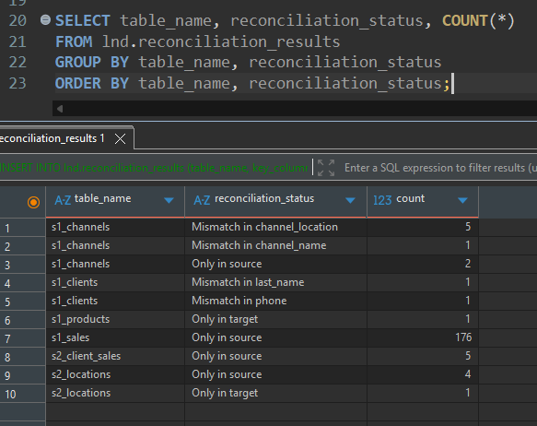
Figure 2. Reconciliation status counts per table
Note: the landing column is named channellocation (a metadata deviation from the source column channel_location); the query was adjusted accordingly.

PYTHON RECONCILIATION
The same reconciliation was repeated in Python using pandas and SQLAlchemy. A single generic function, reconcile_tables, performs a full outer merge (indicator=True) of each source/landing pair on its natural or composite key and classifies each row as Only in source, Only in target, Mismatch in <column>, or Match, keeping only the discrepancies. For columns renamed in landing (channel_location in s1.s1_channels vs channellocation in lnd.lnd_s1_channels), the function takes a column mapping so the two sides are compared correctly; without it, the 5 channel_location mismatches were missed. The src_id and trg_id values are each taken from their own side of the merge, so they are empty where the record does not exist, consistent with the SQL output. The Python results (197 discrepancy rows in total) were compared with lnd.reconciliation_results per table and status, and all counts match, as shown in Figure 3. The output is saved as python_reconciliation_results.csv.
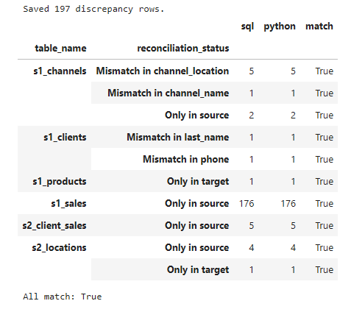
Figure 3. SQL vs Python discrepancy counts

Key findings
- s1_channels: 2 records present in source but missing entirely from landing (channel_id 157, 158); 1 record with a transformed channel_name (CATALOG.ONLINER.BY > CATALOG-ONLINER.BY); 5 records with a transformed channel_location value (Internet > N/A - Internet), all violate the "loaded 1:1, no transformation" rule for the landing layer.
- s1_sales: s1_sales: 176 records exist in the source table but are missing entirely from the landing table (status "Only in source"). These are real missing records, not false positives: the composite key was verified unique on both sides and the comparison used identical text values on both sides, so date-format differences cannot explain the gap. This indicates an incomplete load from SRC to LND.
- s1_clients: 2 records with field-level mismatches (last_name, phone).
- s1_products: 1 record present in landing with no corresponding source record.
- s2_locations: 4 records only in source, 1 only in target; source data also contains a duplicate location_id (40), which is a data integrity concern independent of the reconciliation itself.
- s2_client_sales: 5 records only in source.

Deliverable
Full result set exported as reconciliation_results_202609092033.csv (attached), containing all discrepancy rows with columns table_name, key_column, src_id, trg_id, reconciliation_status.
Python solution: Python_reconciliation.ipynb (executed) and python_reconciliation_results.csv.
Jira epic link:
https://dqdaeau25.atlassian.net/browse/DQ26-2015

